Mc Donalds
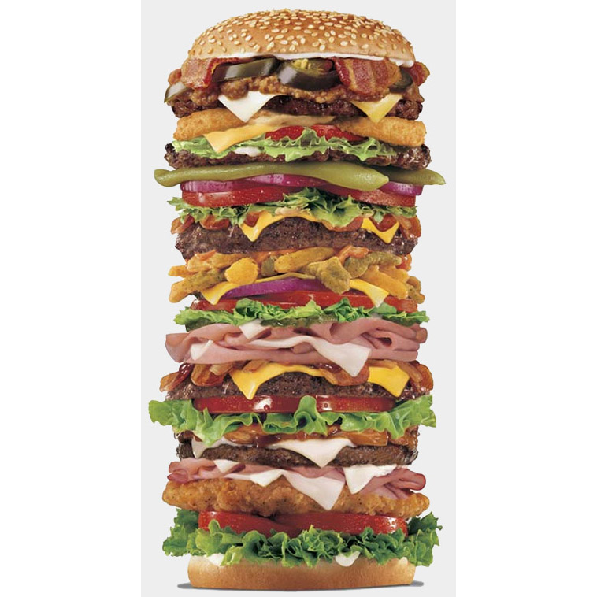
we have a new burger, the XXXXXXXXXXXXXL burger. Whit thirteen X.
The products are:
Three beef burgers
Five slices of tomatoes
Five slices of onions
One chicken burger
Six slices of lecture
Twelve pickles
A halve litter of saus
Speck

This is the combination of a very
Good burger for only 12 euro’s
It taste perfect it is the best burger
Ever.

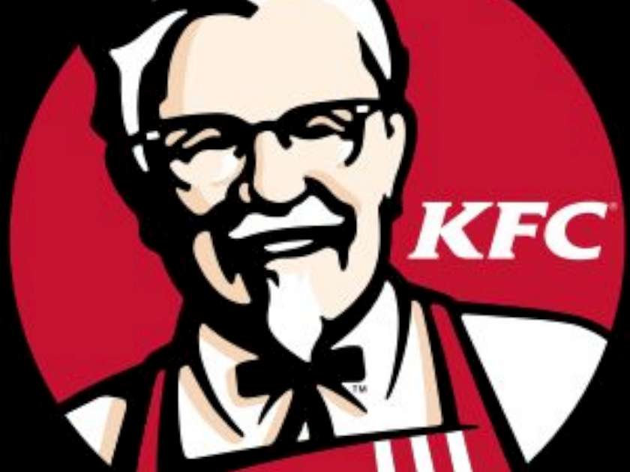
KFC
KFC is the best restaurant in the world.

We sell chicken, milkshakes, france fries
And much more.
The best product is the chicken
